**Project Design Phase-II**

**Data Flow Diagram & User Stories**

|  |  |
| --- | --- |
| Date | 12 April 2025 |
| Team ID | SWTID1742751842 |
| Project Name | ShopEZ: One-Stop Shop for Online Purchases |
| Maximum Marks | 4 Marks |

**Data Flow Diagram:**

This diagram illustrates the **functional flow** between users and components in an e-commerce platform:

* **Customer**: Registers, logs in, browses products, adds to cart, and places orders.
* **User Registration & Login**: Handles user sign-up and authentication, and communicates user account requests to the **Administrator**.
* **Product Browsing & Search**: Allows users to search and view products using data from the system.
* **Cart & Checkout**: Collects selected products and user data, processes payment via the **Payment Gateway**, and sends updates to **Order Management**.
* **Order Management**: Tracks order status, coordinates with **Order Delivery**, and updates both the **Customer** and **Customer Care Executive**.
* **Order Delivery**: Completes the delivery process and sends confirmation to the customer.
* **Customer Care Executive**: Assists users via support tickets and checks order status.
* **Administrator**: Manages user accounts and admin-level tasks.
* **Payment Gateway**: Processes transactions and returns payment status.

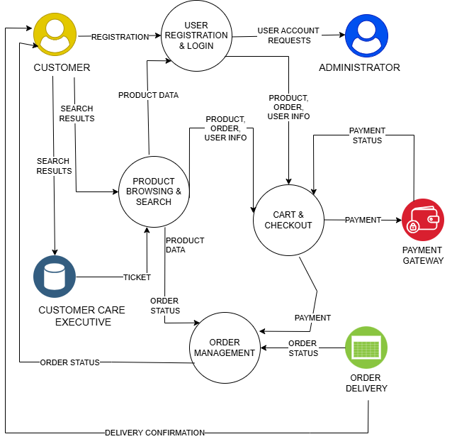

**User Stories**

|  |  |  |  |  |  |  |
| --- | --- | --- | --- | --- | --- | --- |
| **User Type** | **Functional Requirement (Epic)** | **User Story Number** | **User Story / Task** | **Acceptance Criteria** | **Priority** | **Release** |
| **Customer**  (Mobile/Web) | Registration | USN-1 | As a user, I can register by email, password, and confirmation | I can access my account/dashboard after registering | High | Sprint-1 |
| **Customer** | Registration | USN-2 | As a user, I receive a confirmation email after registration | Email is sent and link verifies account | High | Sprint-1 |
| **Customer** | Registration | USN-3 | As a user, I can register using Facebook. | I can access dashboard using Facebook login | Low | Sprint-2 |
| **Customer** | Registration | USN-4 | As a user, I can register using gmail. | I can log in with Gmail without additional signup | Medium | Sprint-1 |
| **Customer** | Login | USN-5 | As a user, I can login with email and password | I can log in and see my dashboard | High | Sprint-1 |
| **Customer** | Rowse/Search | USN-6 | As a user, I can browse and search for products like iPhone 16 | Relevant products appear in search | High | Sprint-2 |
| **Customer** | Cart | USN-7 | As a user, I can add a product to my cart | Product appears in cart with correct details | High | Sprint-2 |
| **Customer** | Checkout | USN-8 | As a user, I can check out securely and make payment | Order is confirmed and receipt is sent | High | Sprint-2 |
| **Customer** | Orders | USN-9 | As a user, I can view my past orders | My orders show correct status and details | Medium | Sprint-3 |
| **Customer** | Support | USN-10 | As a user, I can contact customer care for help | Ticket is created and support can respond | Medium | Sprint-4 |
| **Admin** | Product Management | USN-11 | As an admin, I can add/edit/delete products | Changes reflect in the product list instantly | High | Sprint-1 |
| **Admin** | User Management | USN-12 | As an admin, I can manage user accounts | I can suspend, edit, or reset user data | High | Sprint-3 |
| **Customer Care** | Support Management | USN-13 | As a support agent, I can view and respond to tickets | I can see open tickets and reply to customers | High | Sprint-4 |